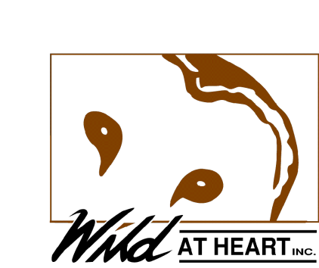
Wild At Heart
Owls and Hawks writing contest

- Contest runs Tuesday October 1, 2013 – Saturday October 19, 2013
- Open to students in 4th through 8th grade
- Open to students in Cave Creek, Desert Hills and Anthem schools
- Only one entry per person
- Entries can be non-fiction, fiction or poetry.
- Entries must feature an Arizona bird of prey (raptor).
  - See attached list for ideas of Arizona raptors
- Entries must be no longer than 500 words.
- Entries will be submitted through the Wild At Heart Facebook page at https://www.facebook.com/WildAtHeartOwl?ref=hl
- Entries will be judged by Wild At Heart team members and will be judged on
  - Creativity
  - Use of language
  - Relevance to the theme.
- The winning author will win for his class a 30 – 45 minute presentation from Wild At Heart which will include live raptors.
- The winning author will also receive a certificate of recognition and a Wild At Heart T-Shirt.

Arizona Birds of Prey (Raptors)
(Birds in Bold are the most common raptors in the Cave Creek, Desert Hills, Anthem area)

Barn Owl
Burrowing Owl
Cactus Ferruginous Pygmy Owl
Great Horned Owl
Elf Owl
Flammulated Owl
Long Eared Owl
Mexican Spotted Owl
Northern Pygmy Owl
Saw-Whet Owl
Short Eared Owl
Western Screech Owl

Bald Eagle
Black Hawk
Caracara
Coopers Hawk
Ferruginous Hawk
Golden Eagle
Goshawk
Harrier Hawk
Harris Hawk
American Kestrel
Osprey
Red Tailed Hawk
Sharp Shinned Hawk
Swainsons Hawk
Zone Tail Hawk
Turkey Vulture

